Introduction
Skin cancer is the most common form of cancer in the United States. In fact, 9,500 people are diagnosed with skin cancer every day. There are multiple types of skin cancer including Basal Cell Carcinoma, Squamous Cell Carcinoma, and Melanoma which range from least aggressive to most. Skin cancer is majorly caused by exposure to the sun, and specifically the UV rays emitted from the sun (Skincancer.org). This means that artificial UV radiation from indoor tanning is also a huge factor in Skin cancer. Other factors also contribute as well, such as age, family history, male gender. In this dataset, we would expect the variables most strongly linked to the response variable to be those reflecting UV exposure, such as the number of sunburns in the past year, use of tanning beds, and other indicators of sun-related risk.

Exploratory Data Analysis
To get started, we explored the potential relationships between the variables, keeping in mind our hypothesis of variables related to UV exposure. First, we tried to analyze the correlation between the variables related to sun exposure:
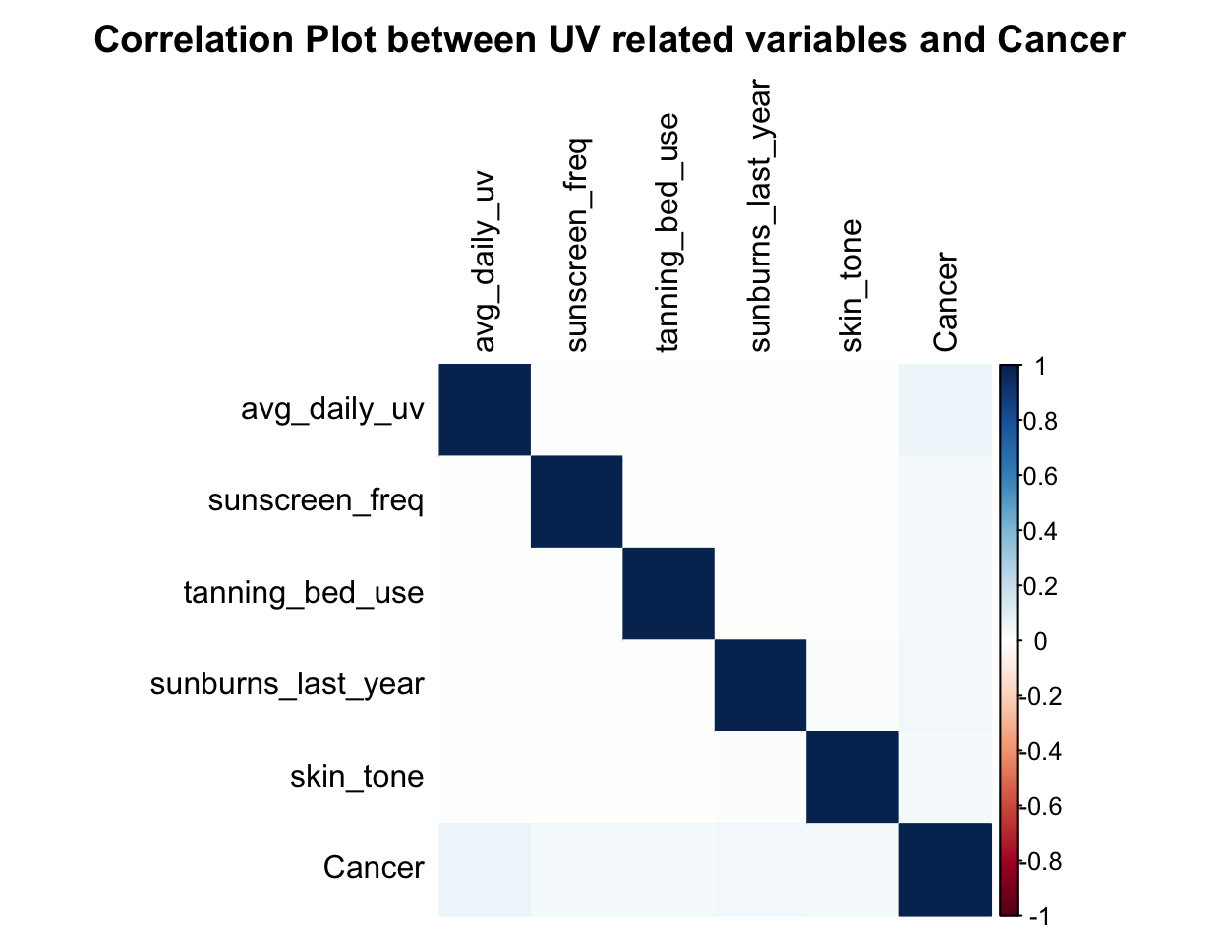
This correlation plot was created by handpicking variables that we believed to be best correlated with UV exposure. Variables that were non numeric were first coerced into factors and then shifted to numeric variables. We then output a correlation matrix and a correlation plot to go with it.
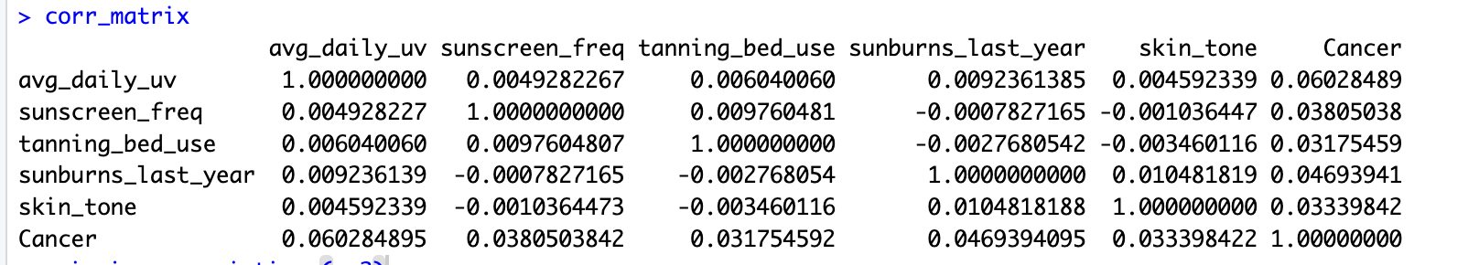
As one can see, this was not the best approach to this dataset as there are many issues with using correlation on numeric-encoded categorical variables. R treated them as continuous, but the numeric codes don’t reflect the actual relationships.

Although the correlation plot was not a great measure for variable importance, it did hint at the potential significance of average daily UV exposure. In order to explore this relationship, we created a box plot:
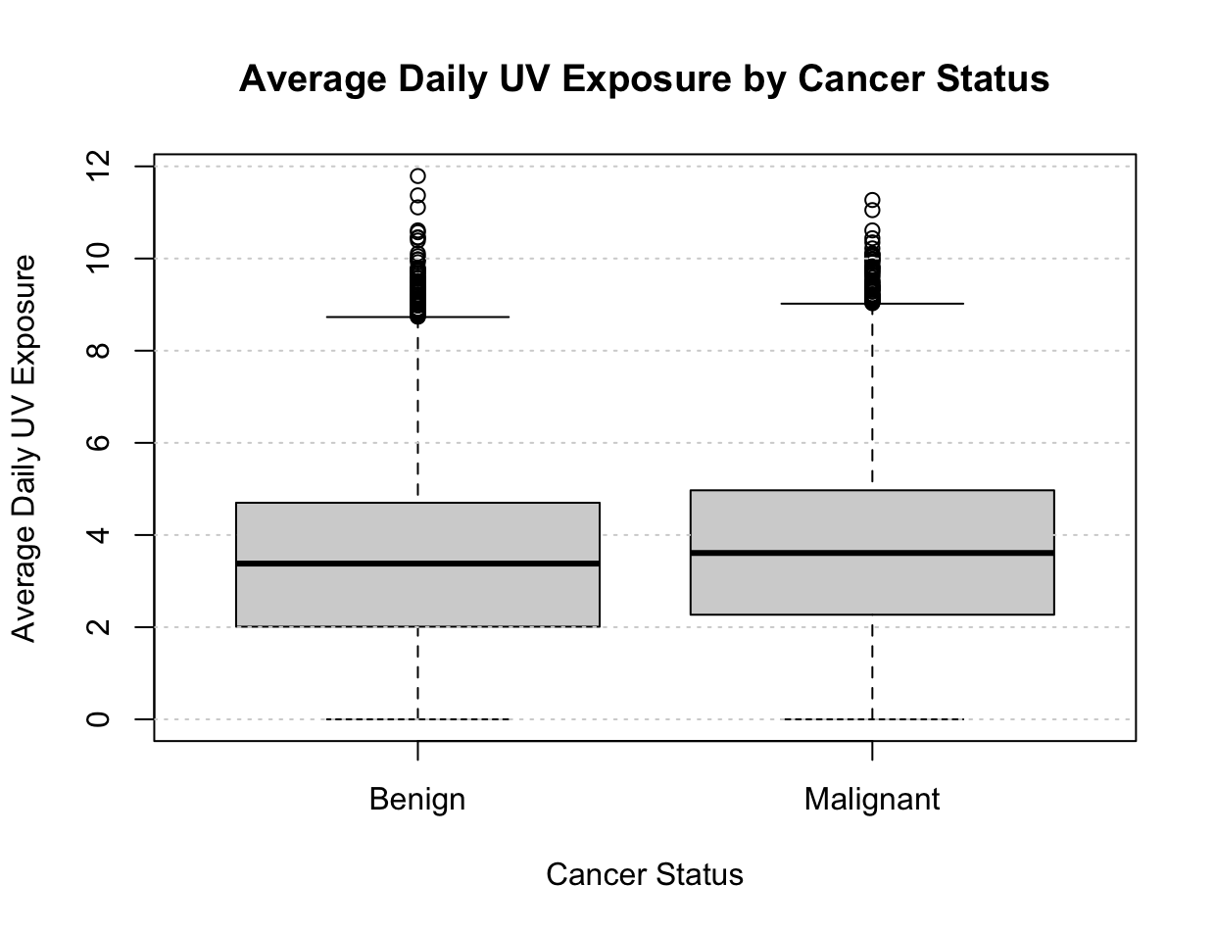
Although subtle, the boxplot shows that individuals with malignant cancer have a higher median average daily UV exposure than patients with benign cancer. The malignant group also displays a wider interquartile range, indicating a greater variability in UV exposure and the need to explore other variables as factors for predicting cancer status. Both groups appear to contain many high-UV outliers, suggesting that extreme UV exposure occurs in both populations of patients.

From external research, we found that sunburns substantially accelerate skin aging and are one of the leading causes of malignant skin cancer (Skin cancer.org). Thus we explored this using an interaction plot:
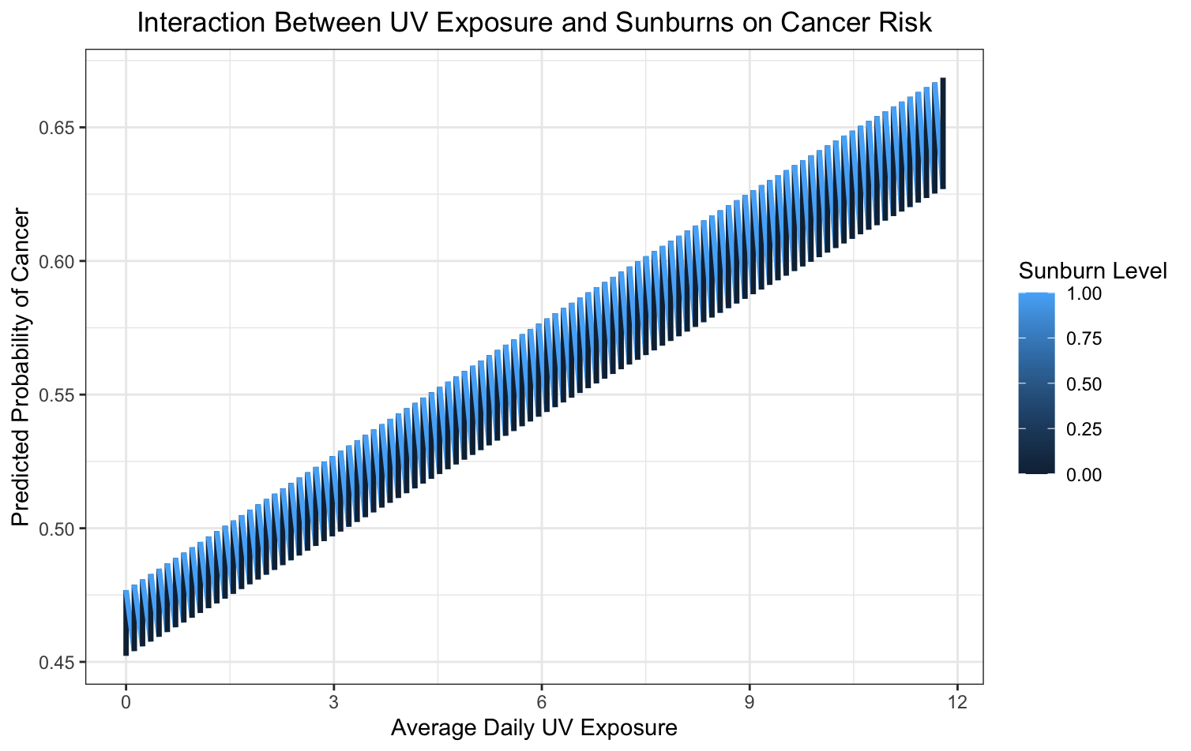
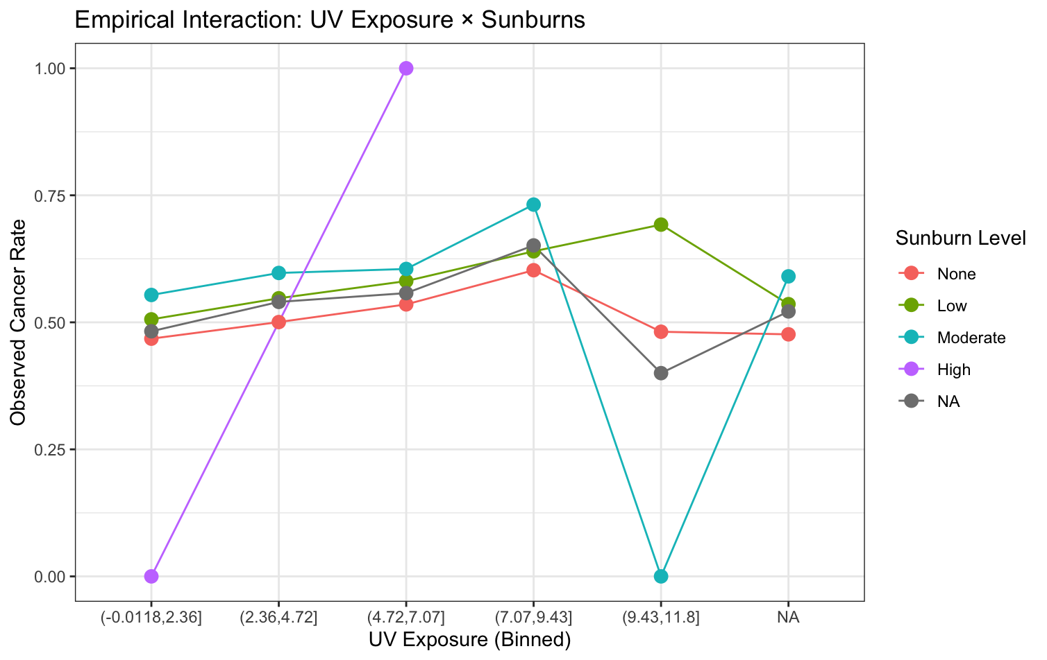
These two graphs show a general trend of increase of cancer rates in correlation with UV exposure and sunburn level with the observed cancer rate. The magnitude of this increase differs by sunburn level, indicating a meaningful interaction. Individuals with moderate and high sunburn histories tend to show sharper fluctuations and higher peak cancer rates at mid-to-high UV levels, suggesting that repeated sunburns amplify the harmful effects of UV exposure which goes in hand with our external research.
Next, we explored the biological variables as an effect on skin cancer, moving past the variables in daily life habits. We visualized cancer prevalence between individuals with and without a family history of skin cancer:
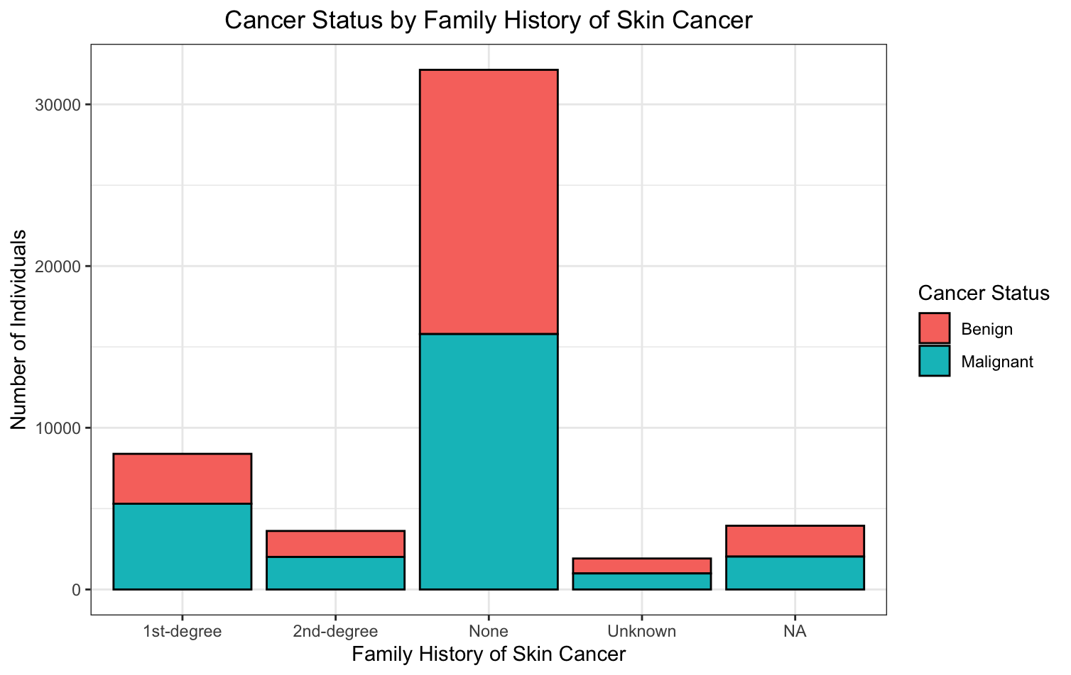
From this stacked bar chart we can see that family history can be a significant predictor of malignant skin cancer. For individuals with no family history, unknown family history, or N/A, the proportions of benign and malignant cancer are relatively equivalent. However, in individuals who have a family history, their skin cancer type tends to be malignant and not benign.

We now zoom back out to all the general variables and fit a variable importance plot in order to see how strongly the variables contribute to cancer prediction:
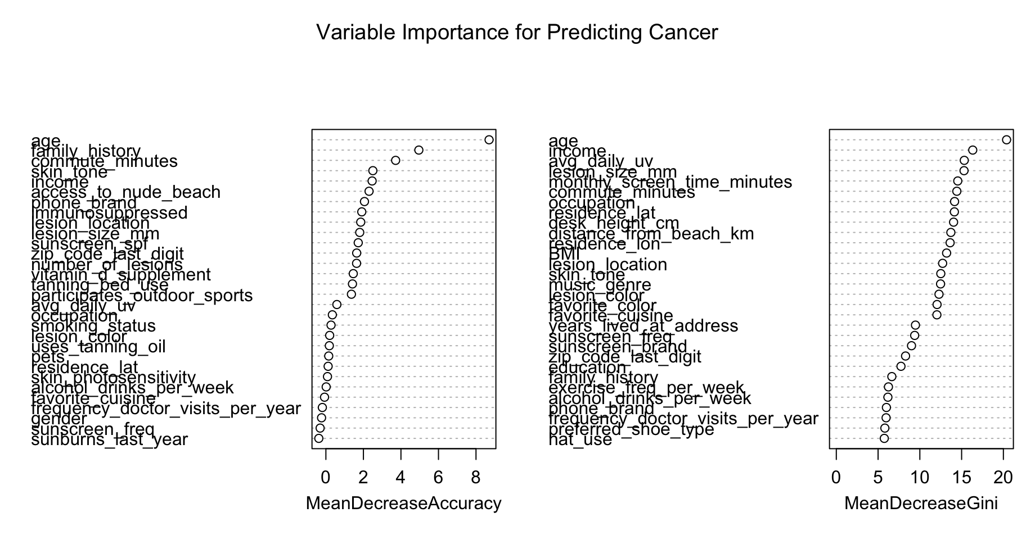
It appears from these Variable Importance graphs that age is the strongest predictor variable of cancer, ranking highest on both Mean Decrease in Accuracy and Mean Decrease in Gini. This indicates that removing age would cause the largest drop in the model’s predictive performance. Other highly influential predictors include family history, income, lesion size (mm), commute minutes, skin tone, and average daily UV exposure which is somewhat surprising because we were expecting daily average UV to rank higher.
Age being the biggest factor in predicting cancer was very interesting so we explore this
relationship more:
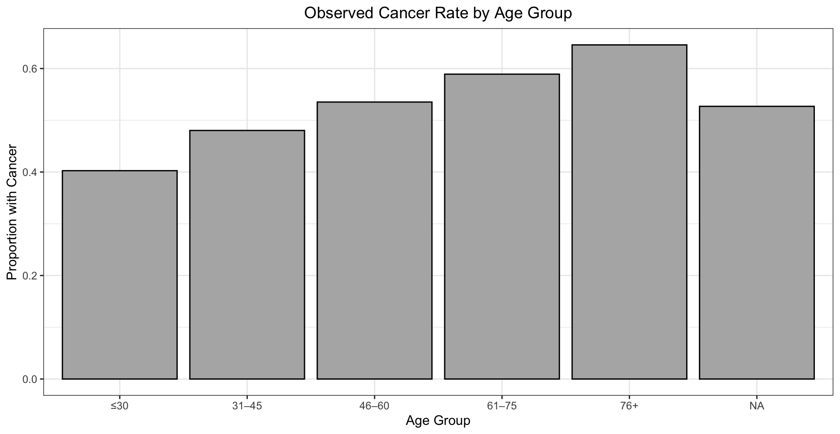
From this plot we can see that the youngest group has the lowest observed cancer rate at about 40%, while the rate steadily rises through middle age and peaks in the 76+ group at approximately 65%. This pattern indicates that age is strongly positively associated with cancer risk, consistent with what the Variable Importance graph showed us.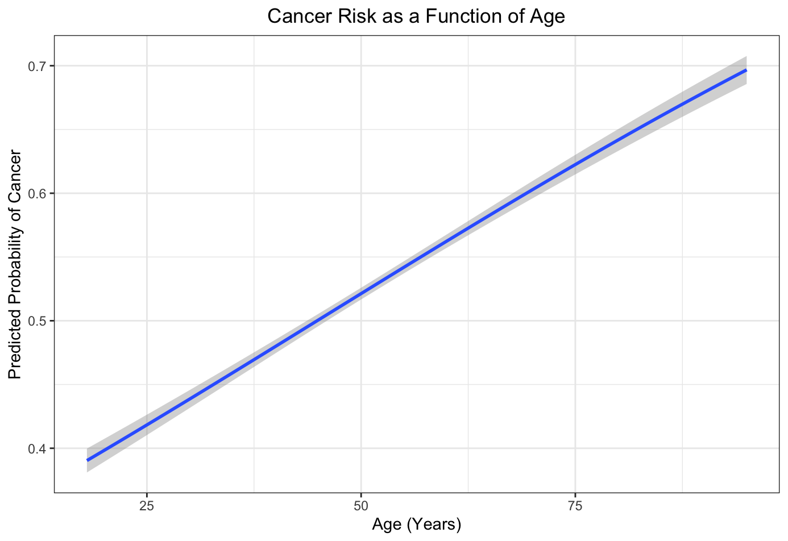

This graph was created by making a cancer a numeric variable and fitting a glm curve on the model. The plot shows a strong, nearly linear increase in the predicted probability of cancer as age increases.

Preprocessing
When cleaning the data, we first addressed the missing values within the dataset. For categorical variables, we replace any missing values with the placeholder “Unknown.” Meanwhile for numerical values, we flagged and replaced any missing values with the median of all known values within the column. Replacing missing values helps us develop a consistent model that aids predictive performance. Moreover, flagging the missing numerical variables helps us preserve the integrity of the data since we replaced any unknowns with the overall median of the column.
Next, we one-hot encoded the categorical variables to convert them into representative measured variables. For instance, the target variable Cancer was standardized to 1’s, representing Malignant tumors, and 0’s, representing Benign tumors.
Before running LASSO, all numerical variables were further standardized to z-score scaling. This step verifies that all the variables are on comparable scales, essential for models such as neural networks.
Finally, we ran a LASSO model using all available predictors in order to help us differentiate between strong and weak predictors. This is done by LASSO shrinking any insignificant variables towards zero (ex: near_high_power_cables, music_genre, desk_height_cm), differentiating them between stronger predictors that are above our practical significance threshold (ex: age, outdoor_job, sunscreen_freq). This step helps us reduce noise by removing unnecessary variables within our model, thus, improving model training.

Candidate Models

XGB Model
Model Interpretation:
The most important variables were identified using the feature importance metrics from the XGBoost model. As shown in the below figure, biological factors dominated the prediction like age, family history, skin tone, showing a good indication that the model learned true medical patterns rather than noisy data.
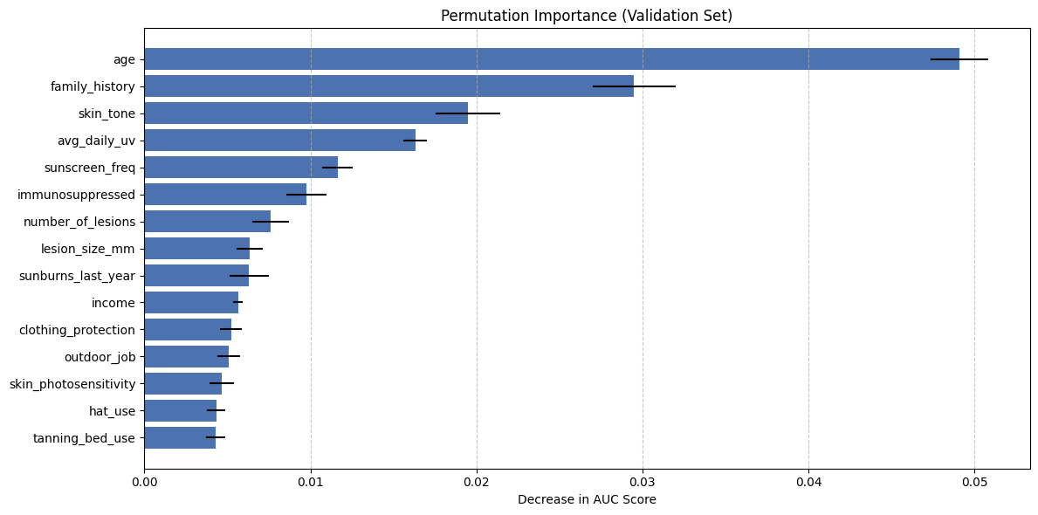
To understand how the model makes decisions, we examined specific directions that were given by the coefficients in Lasso regression where positive coefficients increased risk of skin cancer and vice versa. As seen in the below figure, important factors like increasing age, significantly increased the risk of skin cancer while darker skin tone significantly decreased the risk. This helped give interpretability to our model as we could better understand the specific factors that were being used within it and how it affected their output probabilities.
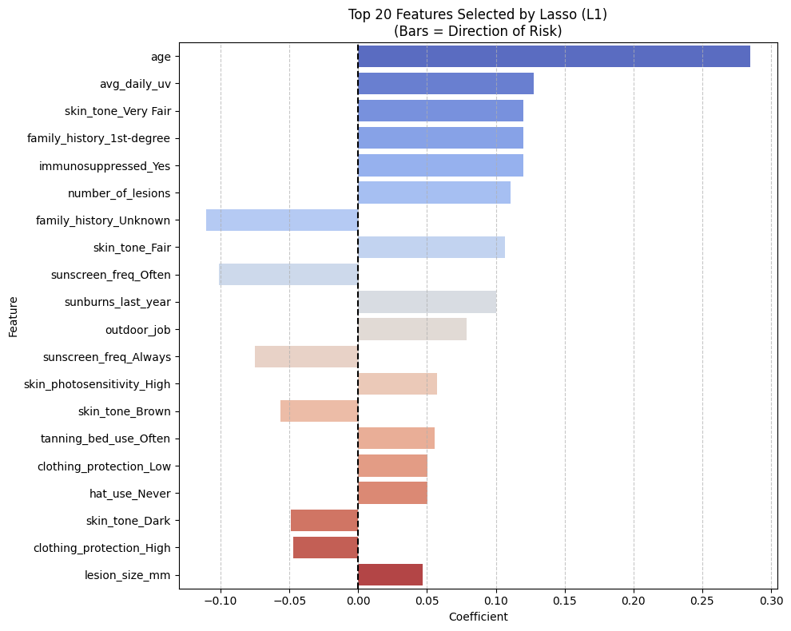
Model Evaluation and Tuning:
To measure performance, we utilized a train/validation split using 20% of the data as validation. We primarily used accuracy as a tuning metric. Upon using cross-validation to benchmark a basic XGBoost model, along with our other candidate models such as the Random Forest and GLM, the XGBoost had the best baseline performance.
The final XGBoost model underwent extensive tuning to prevent both underfitting and overfitting. At first, we set the number of boosting rounds parameter (n_estimators) in the Python implementation to 100 and the maximum tree depth (max_depth) to 4. However, the validation metrics were poor in both training and validation. Thus, we assessed this to indicate underfitting and increased both the boosting rounds and max-depth of our trees. At 5,0000 boosting rounds and a max-depth of 8, we then noticed a significant jump in the training accuracy but as much in the validation AUC, indicating that we had overfit. We decided to use an early stopping strategy for the number of boosting rounds, where we set the parameter at an arbitrarily high number of 10,000 rounds but saved the iteration once the validation AUC began stagnant/decreasing for 100 rounds.
Furthermore, we then ran 5-fold cross validation across a large grid of parameters. We tested max-depths from 3-8, regularization from 1-3, 4 different learning rates, and subsamples from 0.6-0.8. In total, this involved a grid search of 1620 parameter combinations, and thus training 8100 XGBoost model fits. While extremely computationally expensive (taking over an hour to run), it yielded the optimal hyperparameters to set for the tree which we save for the final model which were a learning rate of 0.01, a max-depth of 4, a subsample and column sample 0.6, a a regularized lambda parameter of 2. This was the final model that gave the best performance in terms of accuracy.

GLM Model
This project uses a Generalized Linear Model with a logistic regression to predict an individual’s skin cancer status. Since we are dealing with a binary classification, logistic regression is a good baseline choice to go for to start out our exploration of models. The GLM model estimates the log-odds of cancer as a linear combination of the input predictors. These log-odds are then transformed through the logistic function to produce probability estimates between 0 and 1, which can be interpreted as the predicted risk of cancer for each individual.

Model Interpretation:
We kept the model trained on most of the variables we explored above in the variable importance plot and related to UV such as: age, family history, average daily uv, skin tone, etc.
To measure the performance, we utilized a train/validation split using 20% of the data as validation. Model tuning and validation were then conducted using 10-fold cross-validation on the training portion of the data. We specifically used the area under the AUC serving as the primary tuning metric.
The following is a chart outline the most important predictors in this GLM model. Surprisingly enough, the most important variable was whether or not a patient was immunosuppressed which did not show up in the other models. UV rate also did not make it into the top 10 predictors, which was interesting.
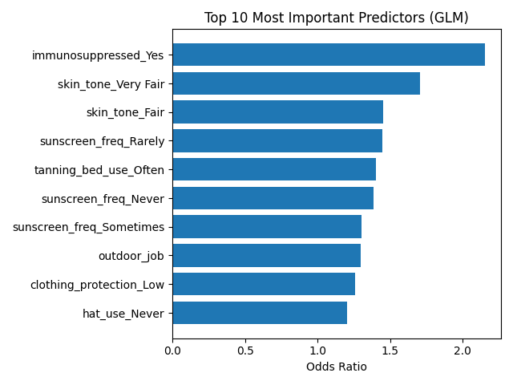

We also outputted an individual model interpretation to further analyze the performance of this model:

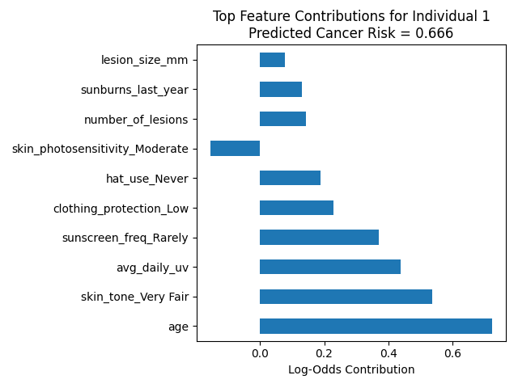
As we can see, this individual’s elevated predicted cancer risk is driven primarily by a combination of age. The model indicates that a lot of day to day behaviors such as sunscreen use, hat use, and clothing protection are meaningful levers that could reduce this person’s modeled risk, even in the presence of biological factors such as age and skin tone.
Overall, the GLM model was a good baseline model to understand the interactions between variables and get the syntax down for future models. It was definitely not a good model for the final submission.

Random Forest Model (All features)
A Random Forest model is used to predict a person’s skin cancer status by building multiple decision trees. These decision trees look at different parts within the data, capturing complex interactions between variables that may not be apparent with a single tree. By first capturing these interactions then aggregating the predictions from all trees, a Random Forest reduces the risk of overfitting, thus improving model accuracy. This process is especially essential when creating insights with our data, due to the non-linearity of the features in this project due to the innumerable amount of categorical and numerical variables involved within the dataset.

Model Interpretation
We trained the model using all variables. In the Top 25 Random Forest Variables graph, the most impactful variables are visualized and ranked by importance. Some of the key predictors include age, average daily UV exposure, family history, and skin tone.
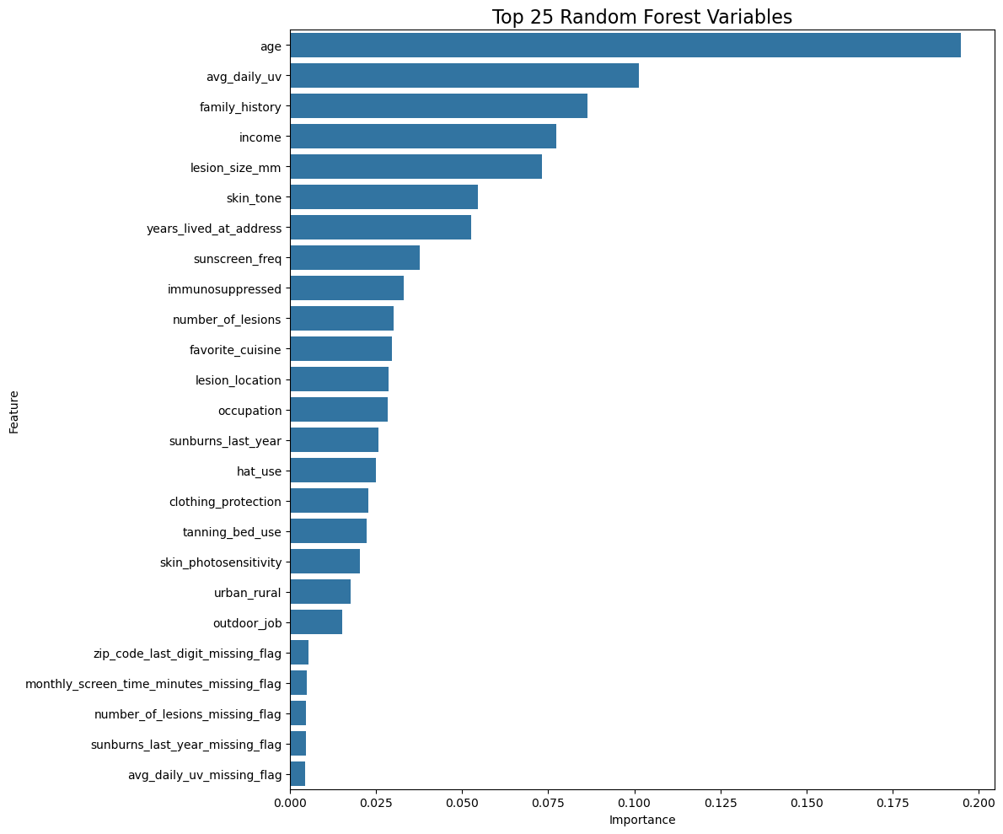
Model Evaluation and Tuning
We split the data into training and validation sets (80/20) and tuned the model using k-fold cross-validation. We used a total of 800 trees due to the figure being a solid middle ground in being large enough to maximize model stability, but also being small enough to not be overly computationally expensive. Likewise, we set the max depth of trees to 10, a solid middle ground in not risking overfitting but also not underfitting the interactions between the variables. The minimum samples per split and minimum samples per leaf were also tweaked with testing to reduce noise and increase stability. We evaluate the efficacy of the model using the area under the AUC as a tuning metric.
Moreover, we created a ROC curve to demonstrate the performance across all possible classification thresholds. This is shown in the Random Forest ROC Curve graph. The model achieved an AUC of 0.622, which means that the model does a solid job in separating malignant from benign cases. However, compared to the other two models, it does fall short in predictive performance.
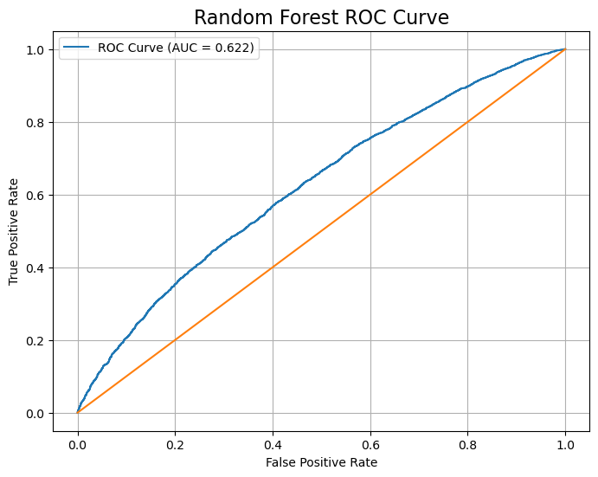

Random Forest Model (Top Features Only)
We created another Random Forest model using only the top predictive features that was identified using our LASSO model from earlier. Although the Random Forest model handles redundant variables very well, we wanted to see if identifying and reducing variables, using LASSO, that create noise (particularly for the other models) would reduce the chances of possible overfitting or reduce any potential masking effects.

Model Interpretation
The model was trained using only the variables identified by LASSO. Some of these features include age, whether the patient is immunosuppressed, family history, and lesion size in millimeters. Some notable variables that are missing from this model that were considered important in the Top 25 Random Variables graph from the previous section include hat use, whether the person lived in an urban or rural environment, and skin tone.

Model Evaluation and Tuning
Similar to the first random tree model, we split the data into training and validation sets (80/20) and tuned the model using k-fold cross-validation. We used a total of 800 trees, a max depth of 10, and tuned the minimum samples per split and per leaf to increase stability, reduce chances of overfitting (or underfitting), reduce noise within the model, and not being overly computationally expensive. We evaluate the efficacy of the model using the ROC AUC as a tuning metric.
A ROC curve was applied to visualize the performance across all possible classification thresholds. This is shown by the Random Forest ROC Curve graph, with the only difference between the first model being that this model only uses the important features. Although the AUC is strong, showcasing that it distinguishes between malignant and benign cases more effectively than the first Random Forest model and generalized linear model, it does not perform on par to our final model, the XGBoost model.
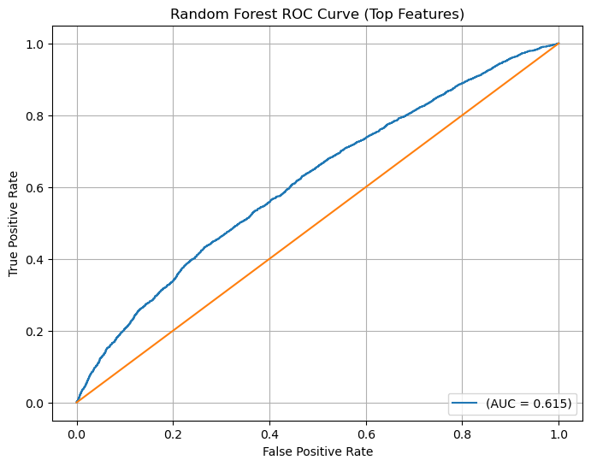

Performance Summary:
Model | Metric Score (Validation Accuracy) | Metric Score (Test Accuracy)
GLM | 0.617 | 59.36%
Random Forest (all vars) | 0.626 | 58.72%
Random Forest (important vars) | 0.615 | 58.25%
Regularized XGB | 0.598 | 60.21%

Discussion of Final Model
Model Selection:
The L1 Regularized XGBoost model was selected for generating the final predictions. This decision was primarily driven by three factors:
- Noise Reduction: The dataset seemingly contained many red herring noisy variables as previously mentioned, and using L1 Regularization allowed us to rigorously eliminate these variables in a mathematical way
- Missingness: The EDA revealed that data was missing not at random, and using this model we engineered specific missing flags, using missingness as a predictive signal.
- Generalization: This model maintained signs of being well fit after hyperparameter tuning and regularization, being less likely to overfit and mapping more deeply complicated patterns and hidden interactions between variables.
Strengths and Weaknesses:
- Strengths: The model is highly robust. By using relatively shallow trees and more aggressive regularization, it avoids memorizing outliers, evidenced by the narrow gap between training and validation metrics. The model also demonstrably captures complex medical interactions like those between skin tone and UV sensitivity that the linear models could not capture.
- Weaknesses: Despite optimization, the final accuracy capped around 60%. This suggests an inherent limit in the dataset’s noisiness. It also required more complexity as it required a multi-step pipeline. Finally, hyperparameter tuning was extremely computationally expensive, given the large number of hyperparameters to set and a grid-search required training thousands of models.

Possible Improvements:
One potential improvement could be combining XGBoost with other machine learning models, and weighing their predictions together to come up with a final prediction. There could be a “wisdom of the crowd” type effect with different models if they were all relatively successful on their own, but this would require a lot more model engineering.
The dataset also relies heavily on self-reported behavioral data like sunscreen use which may not be entirely representative. More genetic or physically proven data markers could provide a lot more signal to the problem and boost its accuracy.

External sources:
https://www.skincancer.org/skin-cancer-information/skin-cancer-facts/
https://www.hopkinsmedicine.org/health/conditions-and-diseases/causes-and-risk-factors-for-skin-cancer
https://www.skincancer.org/risk-factors/sunburn/

